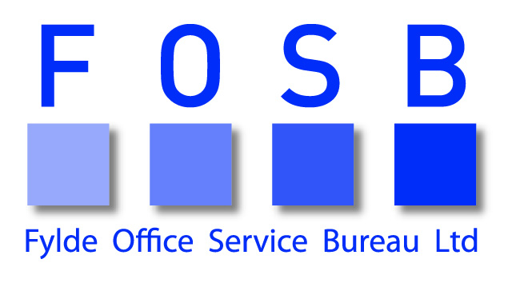

COMPLAINTS POLICY AND PROCEDURE

Complaints Policy

Fylde Office Service Bureau Ltd is committed to providing a high level service to our customers. If you do not receive satisfaction from us we need you to tell us about it. This will help us to improve our standards.

Complaints Procedure

If you have a complaint, please contact Lisa Kendrew, Manager by phone 01253 727034 in the first instance so that we can try to resolve your complaint informally.

At this stage, if you are not satisfied please contact David Parry, Director. You can write to him at:
Fylde Office Service Bureau Ltd
28 Orchard Road
St Annes on Sea
Lancashire
FY8 1PF

Next steps

1. We will send you a letter acknowledging your complaint and asking you to confirm or explain the details set out. We will also let you know the name of the person who will be dealing with your complaint. You can expect to receive our letter within 5 working days of us receiving your complaint.

2. We will record your complaint in our central register within a day of having received it.

3. We will acknowledge your reply to our acknowledgment letter and confirm what will happen next. You can expect to receive our letter within 5 days of your reply.

4. We will then start to investigate your complaint. This will normally involve the following steps;

- We may ask the member of staff who dealt with you to reply to your complaint within 5 days of our request;
- We will then examine the member of staff’s reply and the information you have provided for us. If necessary we may ask you to speak to them. This will take up to 4 days from receiving their reply.

5. David will then invite you to meet him to discuss and hopefully resolve your complaint. He will do this within 5 days of the end of our investigation.

6. Within 2 days of the meeting he will write to you to confirm what took place and any solutions he has agreed with you.

If you do not want a meeting or it is not possible, David will send you a detailed reply to your complaint. This will include his suggestions for resolving the matter. He will do this within 5 days of receiving your confirmation to decline the meeting.

- At this stage, if you are still not satisfied you can write to the REC, our trade association of which we are a member marked for the attention of the Consultancy and Compliance Team, REC, Dorset House, 1st Floor, 27 – 45 Stamford Street, London, SE1 9NT.

If we have to change any of the time scales above, we will let you know and explain why.

