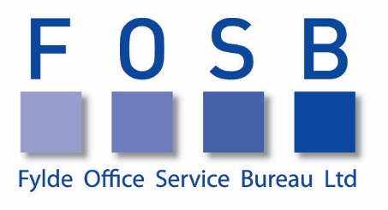

Contents
RM971 – Non Medical Non Clinical Temporary & fixed Term Staff 2
We pride ourselves in selecting the right person for the right job. 3

RM971 – Non Medical Non Clinical Temporary & fixed Term Staff

Fylde Office Service Bureau Ltd has a long history of providing admin and clerical personnel. Through our dedicated staff team, have delivered exceptional customer service, assisting with various recruitment requests to NHS Clients across Lancashire and Cumbria.

w: www.fosb.co.uk
t: 01253 727034
e: info@fosb.com

Fylde Office Service Bureau Ltd
28 Orchard Road
St Annes-On-Sea
Lytham St Annes
Lancashire
FY8 1PF

Key Contacts for Admin & Clerical Staffing within the North West region:

David Parry
Director
dwp@fosb.com
Lisa Kendrew
Manager
lisa@fosb.com
Charlotte Donaghy
Recruitment Consultant
charlotte@fosb.com

Geographical Recruitment Areas include:

- Lancashire
- Cumbria

“We pride ourselves in selecting the right person for the right job.”

FOSB Ltd has been established since 1963 and is one of the most respected providers of recruitment solutions across the Fylde Coast. We have been providing temporary staffing to the NHS for over 17 years.

As qualified and experienced recruitment consultants we can undertake the whole process on your behalf, providing you with a shortlist of recommended candidates who have been interviewed and tested in-house, with references and ID obtained. We work within the NHS Pre-Employment Checklists to ensure that every agency staff member is fully compliant with the NHS Standards.

- Fully Compliant
We have successfully been audited by Crown Commercial Service for Compliance and Recruitment practices and procedures.
- Employment Law
We keep up to date with the latest working regulations and employment law so you can be assured legal requirements are met.
- Pre-employment assessments
We conduct full pre-employment checks used by the NHS
- NI & Tax
All staff will have accurate NI & Tax deduction.
- Our NMNC charge rates
Are fully transparent within the Framework and we pride ourselves on being one of the most cost effective agencies suppling to the NHS, keeping our rates well below the capped amounts as governed by NHS Improvement.
- Holiday Pay
Statutory holiday pay is built into the cost of our agency staff, so you can be confident that workers will receive their entitlement.
- Employer’s NI contributions
Are included in our hourly charge rate so there are no hidden costs.
- GDPR
Fully compliant within the new regulations 25 May 2018.

